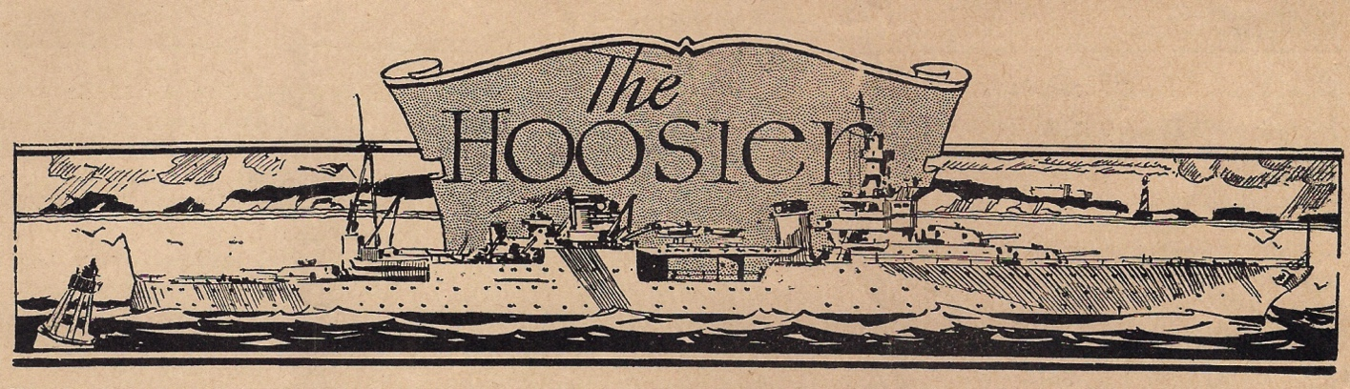
Vol. MMXVI, No. 1 United States Ship Indianapolis CA-35 31 March 2016
71st ANNIVERSARY REUNION

USS Indianapolis CA-35
Survivors Organization
Chairman - Harold Bray
Vice Chairman - Dick Thelen
Treasurer - Elko Perchyshyn
Secretary - Peggy McCall Campo
Master-of-Arms - Don McCall
Chaplain - Ed Harrell
Board - Clarence Hupka
Board - Art Leenerman
Public Relations - Susie Ankrom

Rescue Ships Recovery Ships
USS Bassett APD-73 USS Aylwin DD-355
USS Cecil J Doyle DE-368 USS Cockrell DE-366
USS Dufilho DE-423 USS French DE-367
USS Madison DD-425 USS Helm DD-388
USS Ralph Talbot DD-390
USS Ringness APD-100
USS Register APD-92

Aircraft
PV-1 Ventura - Pilot Lt. Chuck Gwinn
PBY - Pilot Lt. Adrian Marks
PBY - R. Alcorn
PBM - S. Worthington
B17s - 3rd ER Squadron

Medical
USS Hollandia
USS Tranquility AH-14
Samar Medical
Peleliu Medical
Guam Medical Unit 18

REMEMBER
HONOR
CELEBRATE

   
LET US REMEMBER: This July we commemorate the 71st anniversary of the tragic sinking of the USS Indianapolis. Please remember the sacrifice of the 880 men who perished—the largest loss of life at sea in the history of the United States Navy.

LET US HONOR: On behalf of Chairman Harold Bray, the Officers, and Board of Directors of the USS Indianapolis Survivors Organization we invite you to join us as we honor the legacy of the USS Indianapolis.

July 7 - 10, 2016
(YES, IT IS EARLIER THIS YEAR!)
at the Hyatt Regency, Indianapolis

LET US CELEBRATE: At our reunion we will celebrate the lives of the 317 men who survived the sinking of the Indianapolis. And, we will cherish the memories of all Survivors who have passed since 1945.

2016 Survivors Reunion July 7-10
All are welcome: Survivors, their families and friends, lost-at-sea families, former crew, rescue and recovery crew, honorary survivors, Second Watch, USS Indianapolis Museum Gallery and Radio Room volunteers, the crew of the submarine USS Indianapolis SSN-697 and the builders of the new USS Indianapolis LCS 17. Anyone interested in the incredible story of the USS Indianapolis is invited to attend.

At our reunion there will be some exciting scheduled activities and plenty of time to relax and enjoy our time together. The tentative schedule includes an informal welcome reception on Thursday evening, July 7.

A highlight on Friday, July 8, will be a luncheon at the Columbia Club, a long- standing tradition for Survivors and their families and friends. FedEx will provide wheelchair accessible transportation as they have kindly done for us over the years. Seating is limited. By Invitation Only.

A banquet to honor Survivors and the legacy of the USS Indianapolis will be held on Saturday evening, July 9th. Seating is limited. Pre-registration and fee is required. Registration Form is included with this newsletter.

For the convenience of Survivors and their guests, our Memorial Service on Sunday morning, July 10th, will be held at the Hyatt Regency Hotel. This solemn remembrance will honor the entire final sailing crew of the USS Indianapolis.

Throughout the reunion we will offer informative and entertaining programs.
Refer to www.ussindyreunion.com for updates.

To register for the 2016 reunion, please complete and return the attached form or visit www.ussindyreunion.com.

Registration deadline is Thursday, June 9 !

The Hyatt Regency is offering a special room rate of $145 + tax per night for Survivors and their guests attending the reunion. To make your room reservations, please contact the Hyatt directly. Tell the registration staff that you are with the USS Indianapolis Survivors Reunion. There are a limited number of rooms available at the discounted rate, so we encourage you to make your reservations as soon as possible. If you require a handicap accessible room or special accommodations, please mention that when you make your reservation. Survivors please note, our reunion planning team is available to assist you if you have questions or encounter any difficulties with the registration process. We have asked the Hyatt to make sure all Survivors are guaranteed rooms at the discounted rate.

The Hyatt hotel is located in the heart of downtown Indianapolis. It offers comfortable guest rooms and meeting facilities, and a variety of restaurants on site.

Hyatt Regency Indianapolis (Downtown)
One South Capitol Avenue
Indianapolis, IN 46204
Toll-free: 888-421-1442
Telephone: 317-632-1234
* * * * * * * * * *
During the reunion volunteers will be happy to arrange transportation for Survivors and their guests who wish to visit the USS Indianapolis National Memorial. This beautiful monument, located on the Canal Walk, is a tribute to all who served on the heavy cruiser USS Indianapolis.
Transportation will also be provided for Survivors who would like to visit the USS Indianapolis Museum Gallery at the Indiana War Memorial or take a ride on Interstate-465, also known as the USS Indianapolis Memorial Highway.

* * * * * * * * * *

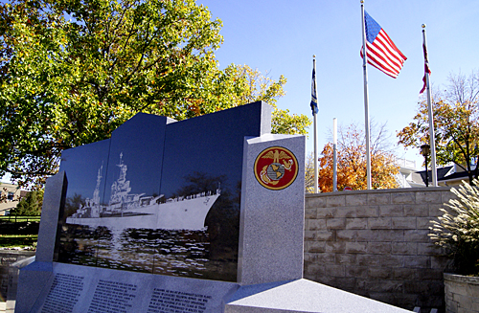

In Memoriam: Since our last newsletter, we have learned of the passing of Survivors George Horvath, Vic Buckett, Harold Eck, Verlin Fortin, Paul McGinnis, Paul Murphy, Felton J. Outland, Florian Stamm, and Lyle Umenhoffer. May they rest in peace.

* * * * * * * * * *
Message from Harold Bray, Chairman - USS Indianapolis Survivors Organization

Dear USS Indianapolis Survivors, families, and friends--I'm very sorry to report that we have lost another great man. Survivor Paul J. Murphy, 91, of Broomfield, Colorado passed away on Sunday, February 21, 2016.

Over more than 20 years Paul served as vice-chairman, treasurer, and chairman of the USS Indianapolis Survivors Organization. It was under his leadership as chairman, and with the assistance of numerous survivors and friends, that our captain Charles B. McVay III was finally exonerated.

Paul and his wife Mary Lou, who served as secretary of the Survivors Organization, devoted countless hours to coordinating reunions and keeping us informed and connected over the decades. Paul and Mary Lou worked tirelessly to compile survivors' stories into the book Only 317 Survived, a beautiful tribute to the surviving crew of the Indianapolis.
On behalf of the Survivors Organization, I extend our sincere sympathy to Mary Lou and the entire Murphy family. Paul always signed his correspondence “smooth sailing.” To him I say, smooth sailing shipmate—you served your country and your fellow survivors well. Rest in peace.

******************
How may I help?

If you would like to help support the USS Indianapolis Survivors Organization, please consider making a charitable gift to honor these great veterans. Funds will provide assistance with travel, lodging, meals, reunion and miscellaneous expenses at the discretion of the Organization.

Donations are tax deductible. The USS Indianapolis Survivors Organization is a 501(c) (19). Please make your check payable to the USS Indianapolis Survivors Organization and mail to:

Elko Perchyshyn, Treasurer
USS Indianapolis Survivors Organization
1073 Orange Avenue East
St. Paul, MN 55106

THANK YOU!

To make a donation by PayPal or credit card, please visit the reunion website at www.ussindyreunion.com

* * * * * * * * * *
For questions about the reunion, contact:
Jim Belcher (540) 256-1676 voice or text
jimbelcherjr@gmail.com or

Elko Perchyshyn 612-270-9345
elko@ukrainiangiftshop.com

* * * * * * * * * *

Remembering 71 Years Ago, to 1945:

This reunion newsletter is dated March 31, 2016, the date of the 71st anniversary of the kamikaze attack on the USS Indianapolis at the battle of Okinawa. On March 31, 1945, nine Indy crew members were lost in the attack. Had history been different, this would have been the largest loss of life on the Indianapolis during World War II. As we all know, that wasn’t the course of history. A special insert has been placed in this newsletter from an unidentified enlisted crewman on Admiral Spruance’s staff who recorded events on this next-to-last cruise.

2015 (Last Year) Survivors Reunion Acknowledgements

We were thrilled again to have so many Survivors along with their families and friends at the 2015 reunion. Joining us were former crew, rescue crew, families of Survivors who have now passed, and families of crew members lost at sea.

Thanks to one and all. Thanks to the Columbia Club once again for hosting our

traditional Friday luncheon. We extend our deepest appreciation to all of our guest speakers who offered their time and talent at our 2015 reunion. And a special Thank You to our many volunteers, our Stewards, who work quietly behind the scenes and make these reunions possible. Without them, it wouldn’t happen! We would especially like to thank Peggy Campo for her herculean efforts to make the special 2015 Reunion a huge success! And congratulations, Peggy, on your appointment as Secretary of the Survivors Organization.

* * * * * * * * * *

USS Indianapolis/ Gwinn "Angel" Scholarship Endowment

August 2, 1945! This was the day that changed the lives of the Indianapolis Survivors forever. Navy pilot Lieutenant Wilbur C. “Chuck” Gwinn—your “angel”—spotted you in the ocean. Joining us at the Indy reunions are Chuck’s widow Norma Gwinn, and daughters Jane and Carol. Just take a moment to consider the impact of the sighting. Chuck saved 317 men but each of you had children, grandchildren, and great-grandchildren. Generations of family members were impacted on that fateful day. To ensure that the Indianapolis story will continue to be told in the future, the Gwinn family has endowed a scholarship for heirs
of Survivors, lost at sea crew, rescue crew, and honorary survivors. For details, visit:
www.gtrcf.org/scholarships/uss-indianapolis-gwinn-angel-scholarship-application.html

USS Indianapolis LCS-17

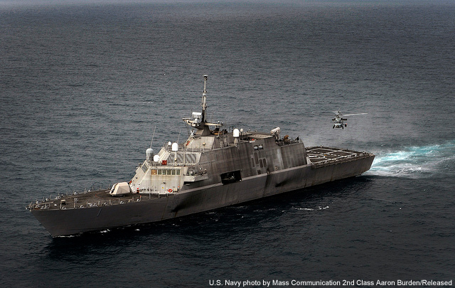
USS Freedom (LCS-1), the first in the Lockheed Martin Independence Class of littoral combat ships. USS Indianapolis LCS-17 will be of this class.

Retired Navy Captain Glen Sears spoke on behalf of Lockheed Martin at previous reunions about the USS Indianapolis to be built at Merinette, Wisconsin. The ship is now under construction, and we hope to have a special program and speaker representing the shipbuilders at the 2016 reunion to answer your questions regarding the next USS Indianapolis, LCS-17.
The littoral combat ship (LCS) is a new family of surface ships for the US Navy. The LCS is a fast, highly maneuverable, networked surface combat ship, which is a specialized variant of the family of US future surface combat ships known as DD(X).
LCS is designed to satisfy the urgent requirement for shallow draft vessels to operate in the littoral (coastal waters) to counter growing potential threats of coastal mines, quiet diesel submarines and the potential to carry explosives and terrorists on small, fast, armed boats.

Registration deadline is Thursday, June 9 !

Banquet Speaker Announcement

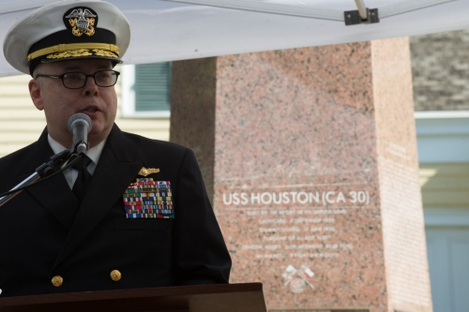
Rear Admiral Samuel J. Cox, USN (Ret.), Director of Naval History, speaks at the USS Houston (CA-30) Memorial Service held in Houston, Texas on 5 March 2016.

The USS Indianapolis Survivors Organization is pleased to announce our keynote speaker for the 2016 Reunion banquet will be Rear Admiral Samuel J. Cox, who presently serves as Director of the Naval History and Heritage Command, the Chief Historian of the Navy! Admiral Cox graciously accepted our invitation to speak at the 71st Anniversary Reunion He recently spoke at the USS Houston CA-30 memorial service in Texas. His speech is available to view online. Go to http://www.history.navy.mil/about-us/leadership/director/USSHoustonSpeech.html

* * * * * * * * * *
Take note! Most programs and events during the Reunion are open to the public at no-charge EXCEPT the Saturday evening banquet. Registration and fee are required in advance…deadline June 9, and Registration form is attached to this newsletter! Seating is very limited…do not wait to register!

* * * * * * * * * *
Mailing List Updates/Adds:

May we convert you from our U.S. postal service mailing list to our email list? Or add someone you know who would like to be on our mailing list for invitations and newsletters? Please send your name and email address to Organization Secretary Peggy Campo at pcampo4@yahoo.com
or phone it in to one of the numbers listed in the “For More Information” box elsewhere in this Newsletter.

Memorial Service Speaker Announcement!
The USS Indianapolis Survivors Organization is pleased to announce our 2016 Memorial Service Speaker on Sunday morning July 10 will be our very dear friend and USS Indianapolis family member, Bill Toti.
William J. Toti was named president of Cubic Global Defense last year.
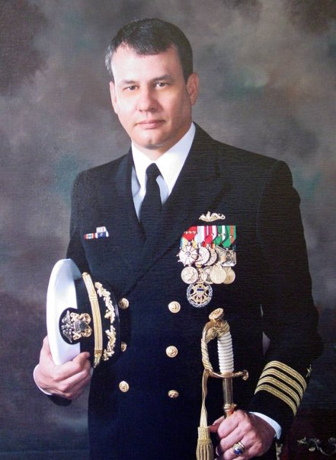
As most of our Indy family knows, Bill served more than 26 years in the U.S. Navy. Bill was the last captain of the USS Indianapolis SSN-697 and he decommissioned her. At Capt. Toti’s invitation, several USS Indianapolis CA-35 crewmen stood with the fast attack sub crew at that final ceremony in Hawaii.
For an interesting peek at Bill during his Navy days, after the USS Indianapolis SSN-697, browser search “60 Minutes-- CAPT Bill Toti and Giant Shadow - YouTube” and select that program.

*****************************

Naval History- Four Generations of USS Indianapolis U.S. Navy Vessels

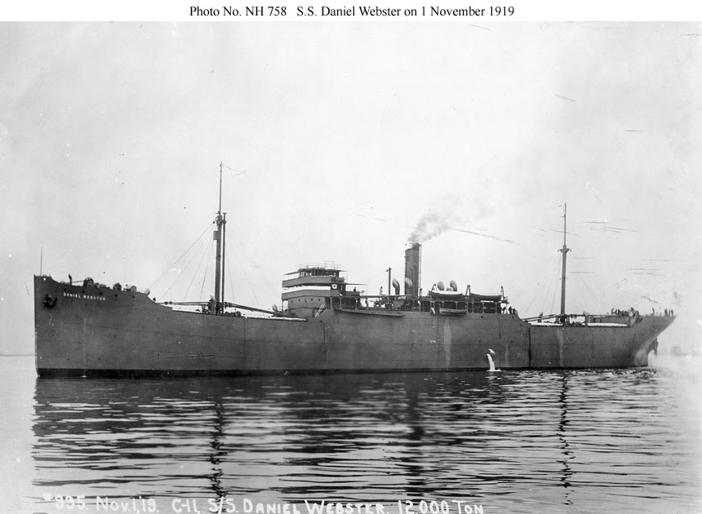
USS Indianapolis ID-3865 Cargo Ship 1918-1919
Length 439.5 ft ; Speed 11 knots

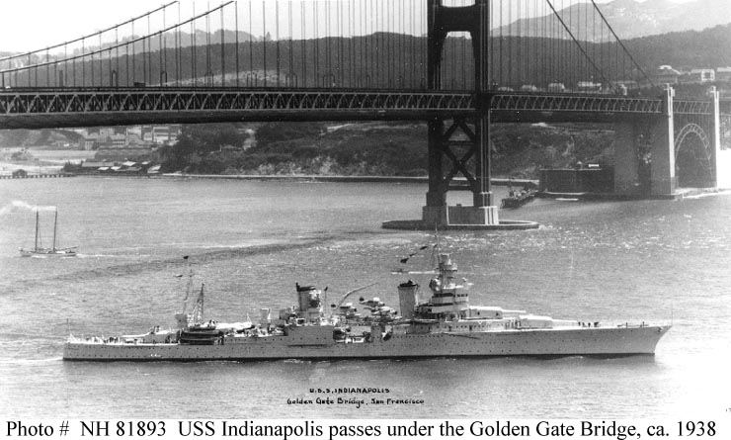
USS Indianapolis CA-35 Heavy Cruiser 1932-1945
Length 610 ft ; Speed 32.7 knots (36 mph)

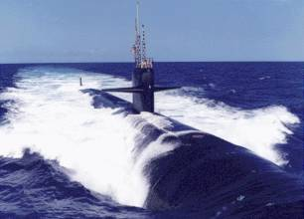
USS Indianapolis SSN-697 Nuclear Submarine 1980-1998
Length 362 ft ; Speed (fast- not published; ask Bill Toti)

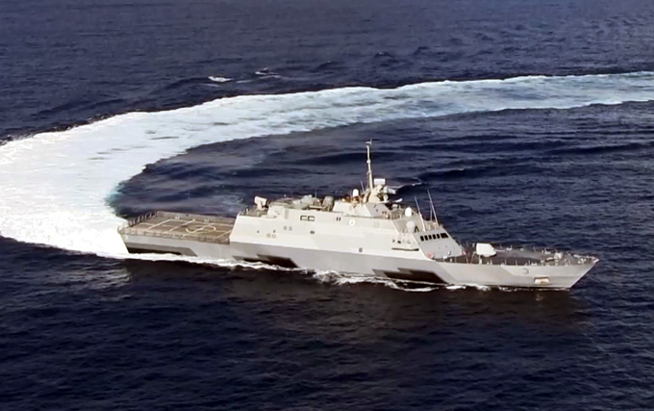
USS Indianapolis (Freedom Class) LCS-17 Littoral Combat Ship
(Pictured is USS Fort Worth LCS-3; Indy under construction)
Length 378 ft ; Speed 45 knots (52 mph)

